**TOOLS USED-**

1. 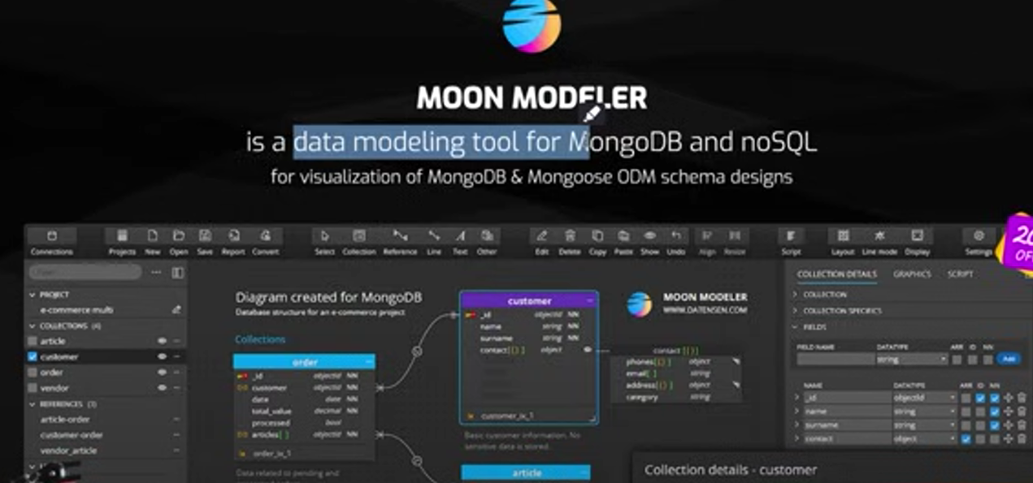**Moon Modeler – For data modelling the fields.  
   its alternates – Eraser.io tool.**

**Helper – to achieve the data modelling we need it available options in market are –**

**Prisma, mongoose – help to store data- elegant object modeling for node.js**

1. **Practical – Code sandbox, github codespaces, stackblitz**

**- cloud coding**